**608 FINAL REVIEW**

**SORTING:**

Input: a sequence of items (does not need to be numbers, but must be comparable)

Output: a permutation of the input sequence with items in increasing or decreasing order

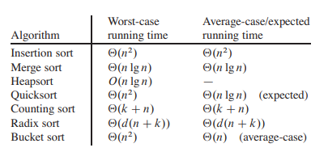

**Selection Sort:**

1) Look for the minimum – O(n)

2) bring it to the front, shift all numbers to the left of min to the right and store min – O(n)

3) recurse/repeat on rest of array O(n-1)

T(n) = T(n-1) + O(n)

N + (n-1) + (n-2) ….. + 1 🡪 ALWAYS O(n^2)

**Insertion Sort:**

Simple sorting algorithm that works similar to the way you sort playing cards in your hand. Array is virtually split into a sorted and unsorted part. Values from unsorted part are picked and placed at correct spot in sorted part. (NOTE, BEST CASE IS O(n) IF ITEMS ALREADY IN ORDER.. O(n^2) is worst case)

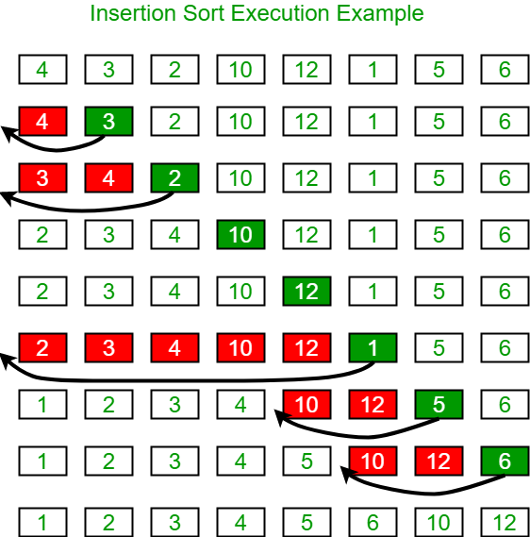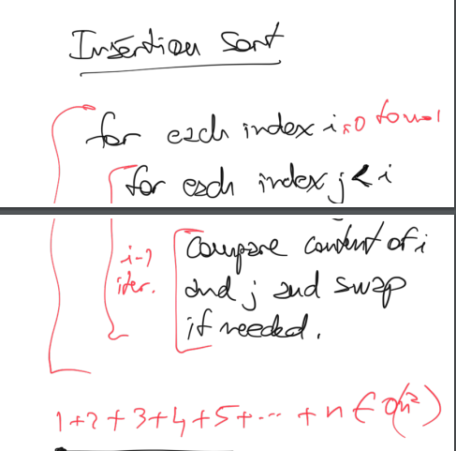

**Bubble Sort:**

Simplest sorting algorithm that works by repeatedly swapping the adjacent elements if they are in order. ALWAYS O(n^2), UNLESS THERE ARE NO SWAPS, IT CAN STOP EARLY

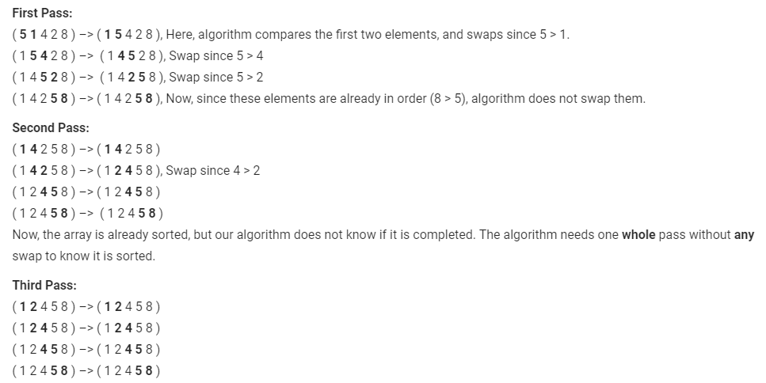

**CONCLUSION: Any algorithm that removes at most one inversion for each comparison needs at least O(n^2) comparisons in the worst case. (Selection, Insertion, and Bubble Sort)**

**Tree Sort:**

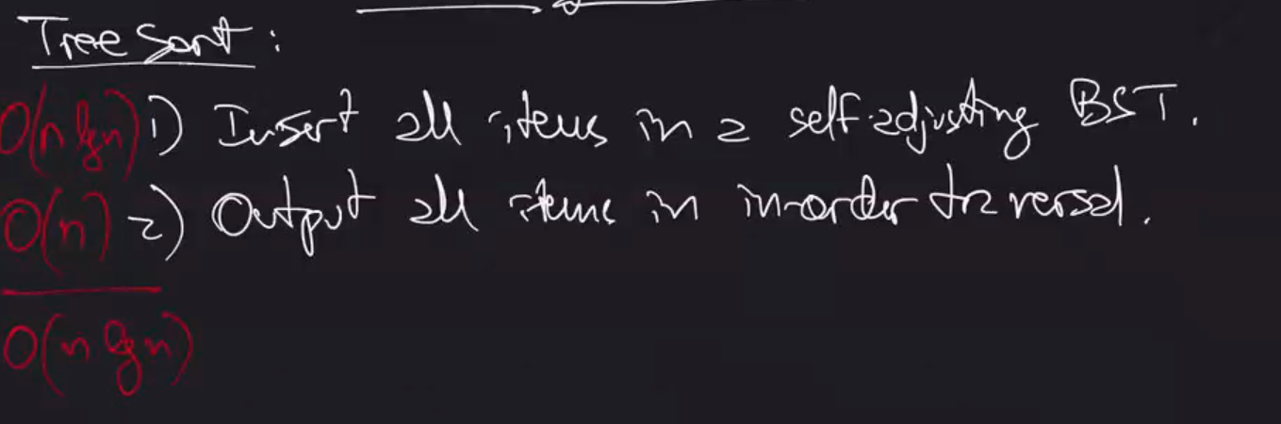

**Quick Sort:**

Divide and Conquer algorithm that selects an element as the pivot and partitions the given array around the selected pivot.

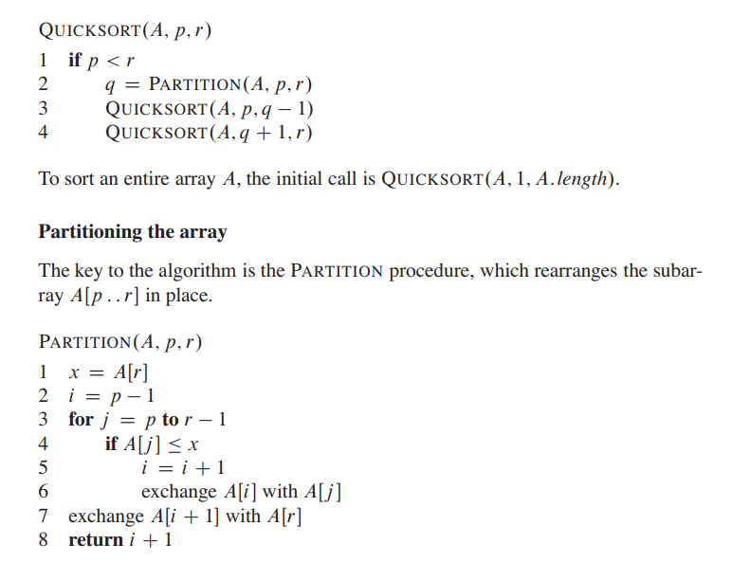

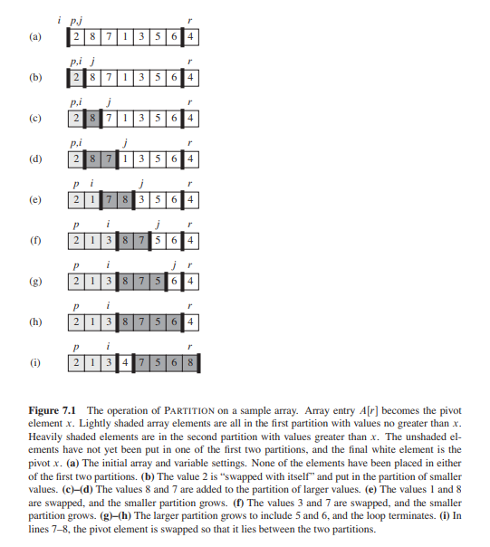

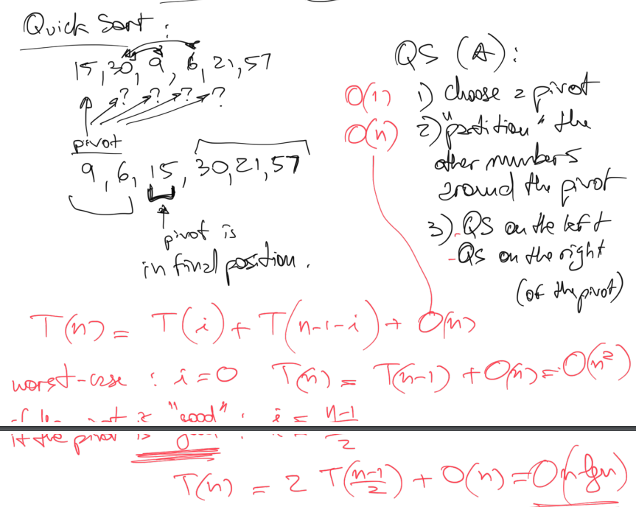

**Note:**

Quick sort time depends heavily on choice of pivot

T(i) = i items on left

T(n-1-i) = total items minus pivot minus items on left, aka items on right

Worst case is when pivot would be first item, i = 0… then **O(n^2)**

**But if pivot is good, i = (n-1)/2 -->** **O(n lg n)**

**Merge Sort:**

Divide and conquer algorithm that divides input array into two halves, calls itself for the two halves and then merges the two sorted halves.

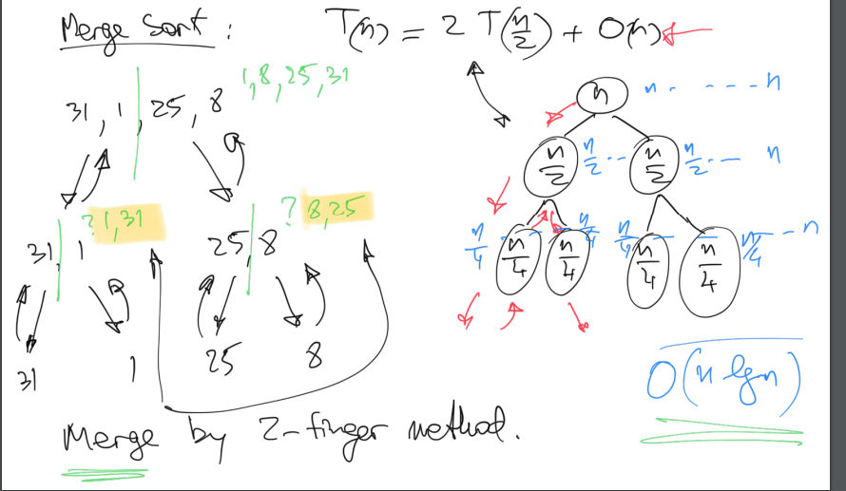

Asymptotic Notation for any algorithm that grows at any function of log (such as n log n), always grows so small so it is ignored and just stated as:

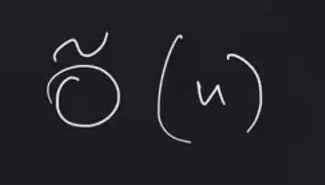

Comparison Decision Tree:

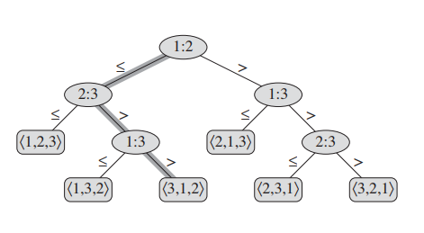

**Note:**

There is one leaf for each possible permutation of the sorted output. (For each output, we go through one path, hence the longest possible path is the height of the tree)

The worst-case running time is the max number of comparison (height of tree)

It is a binary tree, and the number of leaves is equal to the number of permutations possible (n! leaves)

If a tree has n nodes, the height is lg n.

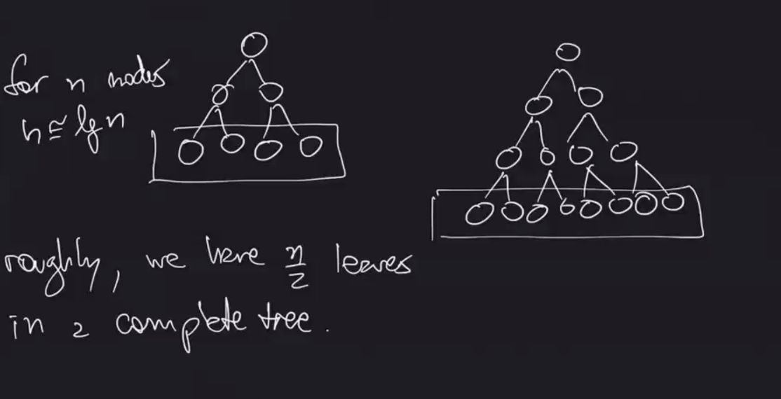

FOR LOWER BOUND: cannot take less than n lg n

Proof that worst-case running time of these comparison trees is the height of tree (lg(2n!))

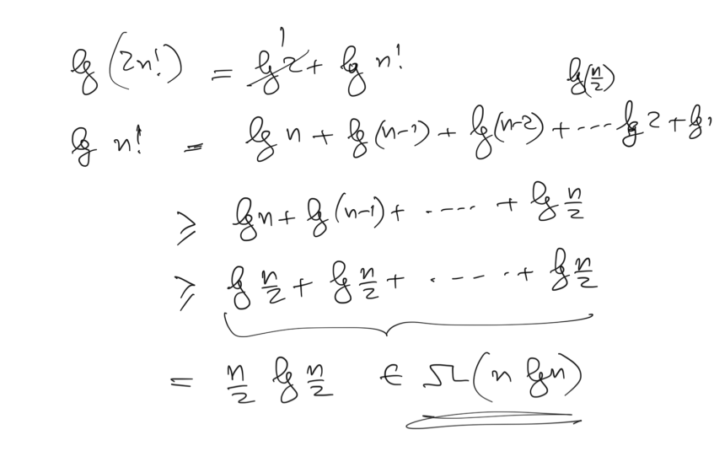

Overview:

Quadratic Sorts O(n^2)

* Insertion Sort
* Selection Sort
* Bubble Sort

O(n lg n)

* Merge Sort
* Quick Sort
* Tree Sort

Any Comparison-based sorting for lower bound cannot be done better than n lg n

* Means that merge, quick, tree sort are most optimal comparison-based sorts
* lg(n!) no less than O(n lg n)

**Sorting in Linear Time:**

**Radix Sort:**

Assumptions:

Items to be sorted have a maximum value (k) (we know the range)

It should not do comparisons (we want to improve on comparison-based lower bound that is O(n lg n))

Must be stable (sort input array using counting sort (or any stable sort) according to the i’th digit)

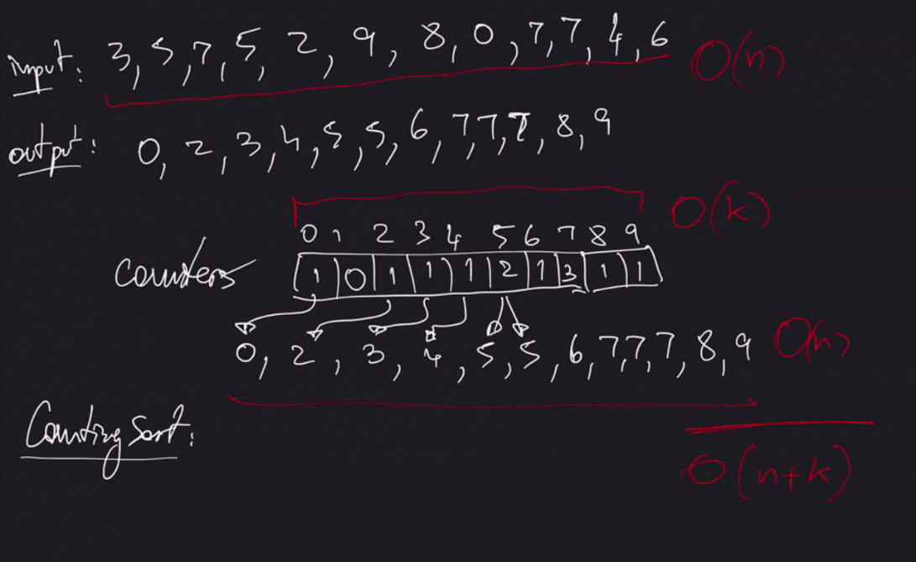

**Note:**

n is the number of elements to be sorted, k is the maximum value (range)

If k is close to n, it is a linear algorithm. If k is a very large number, it is not worth using radix sort.

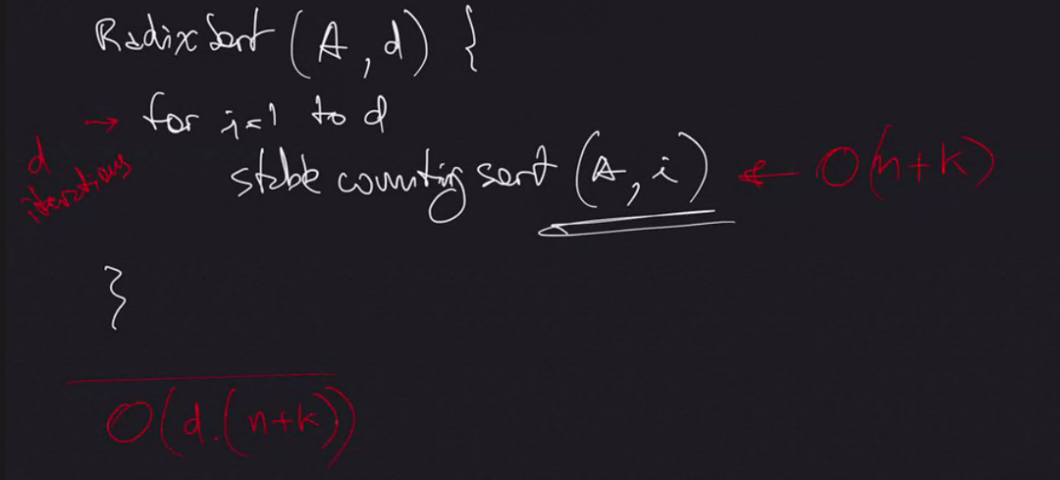

**Note:**

d is the number of digits

When d is contant and k is O(n), Radix Sort is O(n) – LINEAR TIME

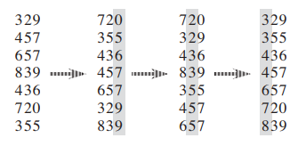

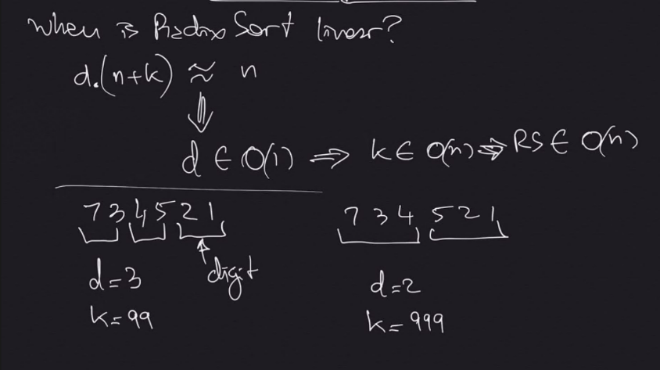

**Stable Counting Sort:**

Linear sorting algorithm that keeps the repetitions in the output in the same order that they were in input.

Assumes that each of the n input elements is an integer in range 0 to k. When k = O(n), sort runs in O(n).

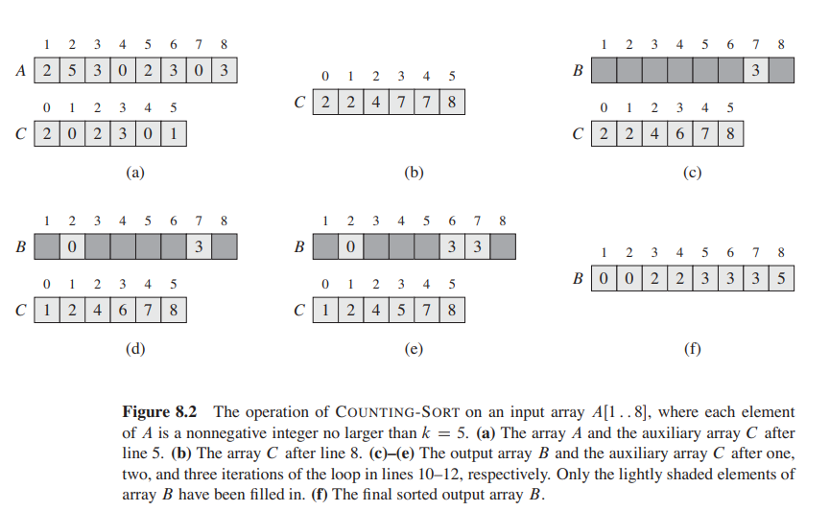

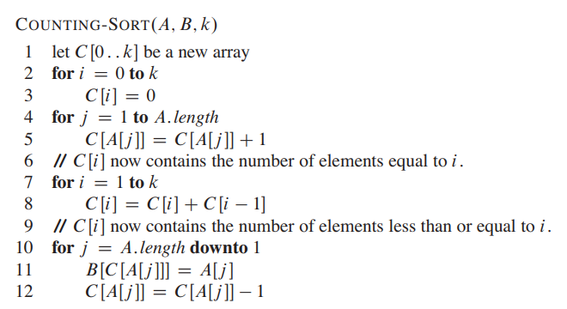

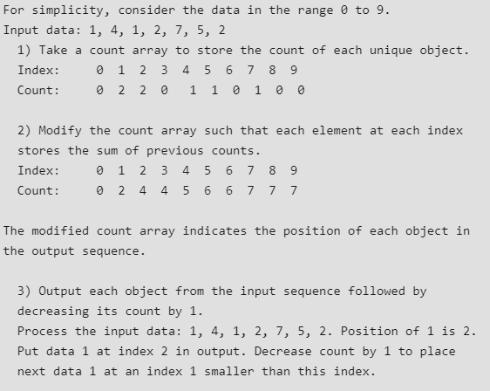

**Sorting Input Information**

* **Max Range -> Radix Sort**
  + Radix Sort takes advantage of knowing the maximum range (bits of each individual input – sorts each digit in order)
* **Distribution on the range -> Bucket Sort**

Bucket Sort takes advantage of range of the numbers in input

**Bucket Sort:**

Assumes that input has a uniform distribution and has average-case run time of O(n). Whereas counting sort assumes the input consists of integers in a small range, bucket sort assumes that input is randomly generated and distributed uniformly over the interval [0,1).

Puts the items in “buckets” and sorts each bucket.

Number of items in each bucket is approximately (n / number of buckets) if items are uniformly distributed.

If distribution is uniform, divide the range into n buckets.

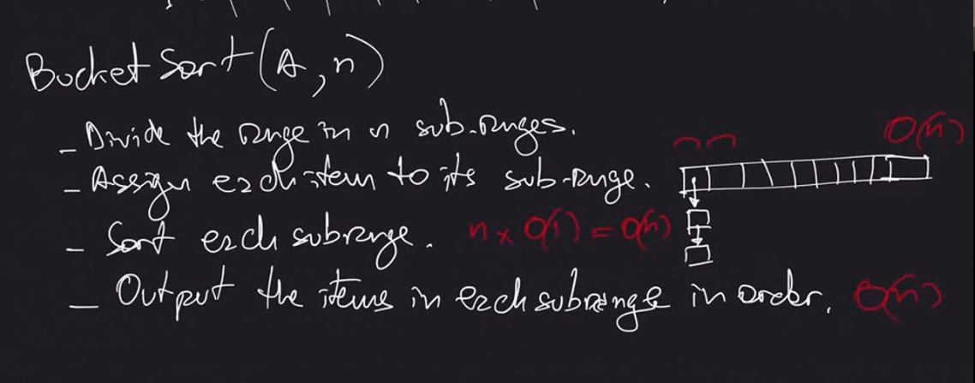

* Create an array of size n
* Each position corresponds to one of these buckets
* Need reference to list in each spot in array so that more than 1 item can be stored in each bucket if needed
* Get first item of input, do some math operation to determine which range it is in, then put it in the array in that list/bucket that corresponds.

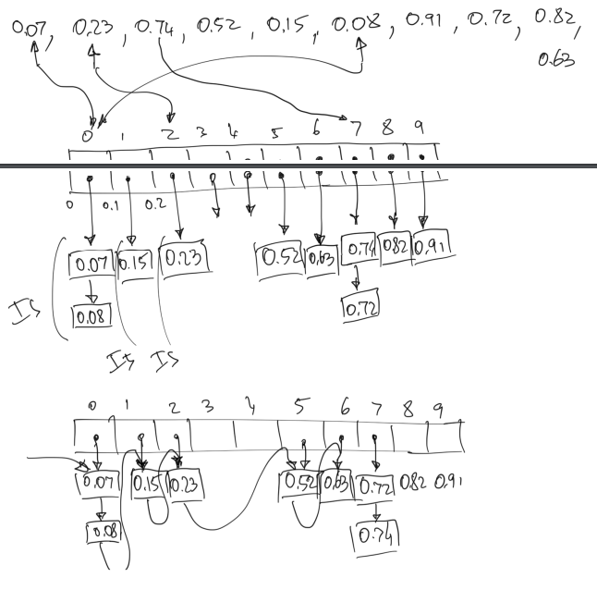

**Dynamic Programming**

Dynamic programming is a “smart brute force” algorithm (brute force: try all possibilities)

Typically used when solving optimization problems.

Follows Sub Problem Optimality – the best solution for entire problem must be equal to combination of best solution for the parts in order to apply dynamic programming

**Cutting Rods Example O(n^2)**

Input: A length n and a table of prices

Output: The maximum revenue obtainable for rods whose length sums to n, computed as sums of prices of individual rods

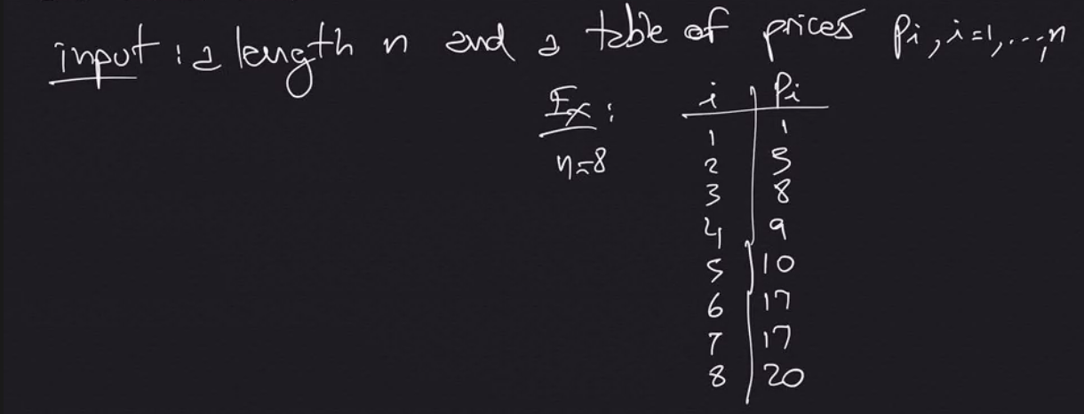

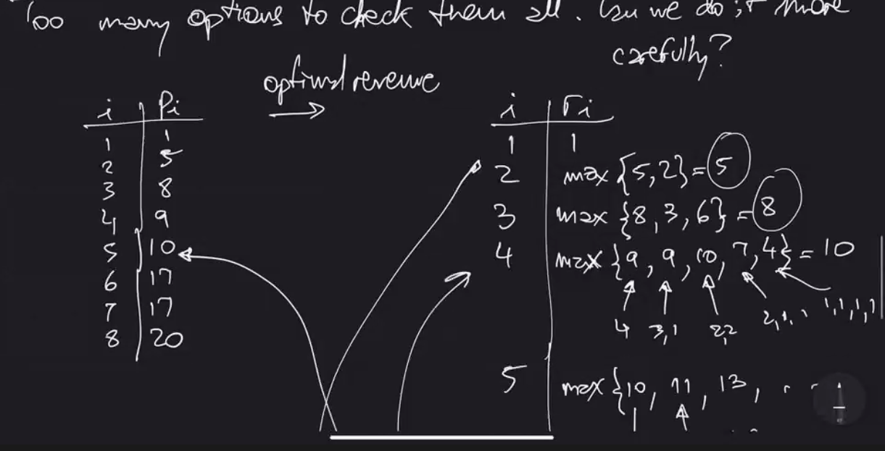

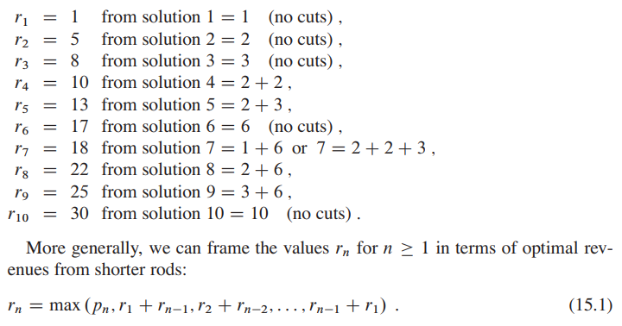

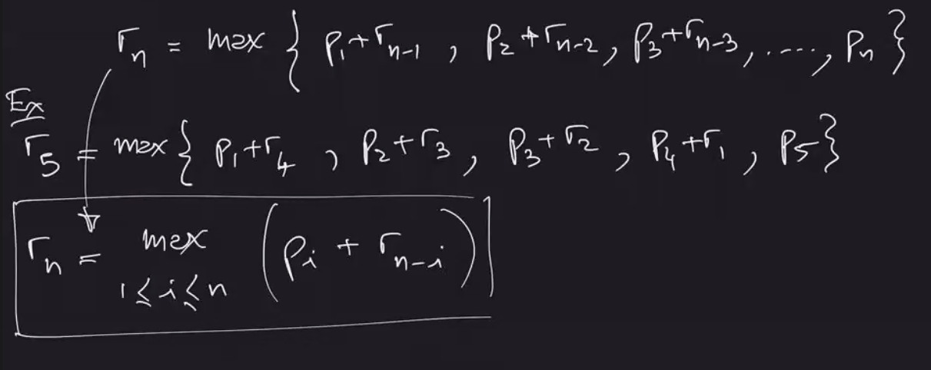

Without memoization O(2^n):

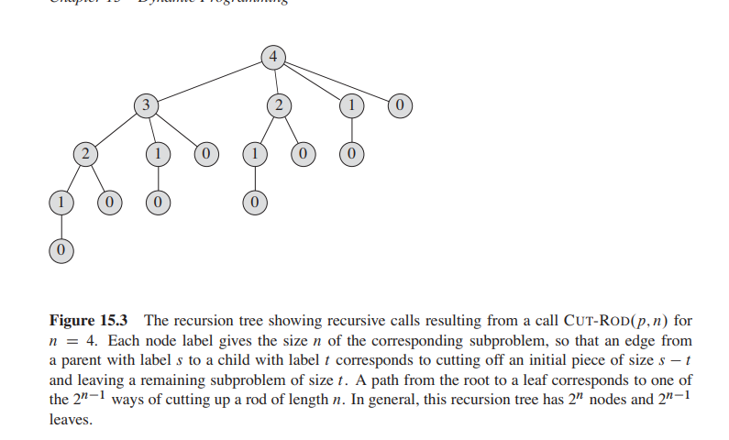

With memoization O(n^2):

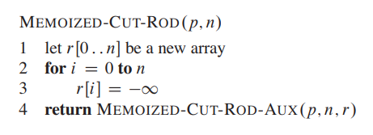

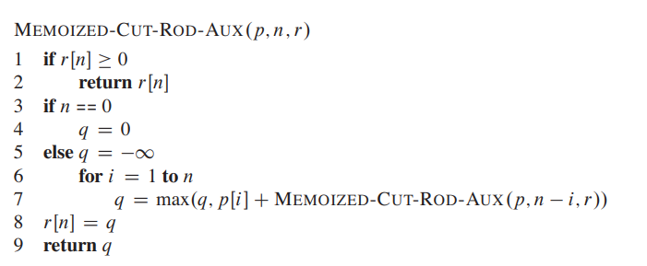

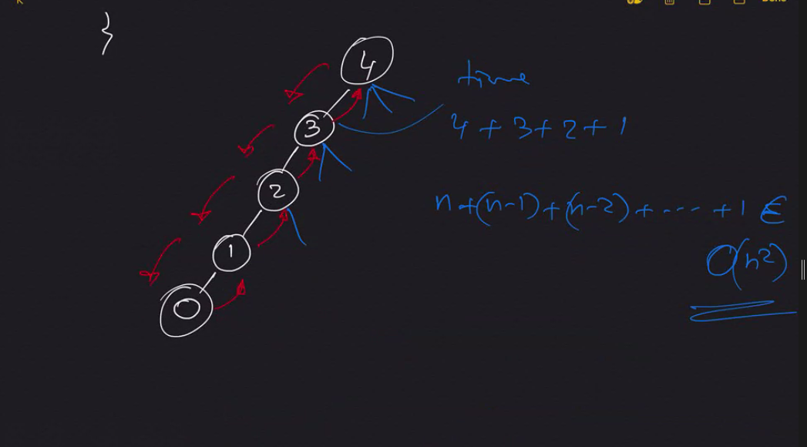

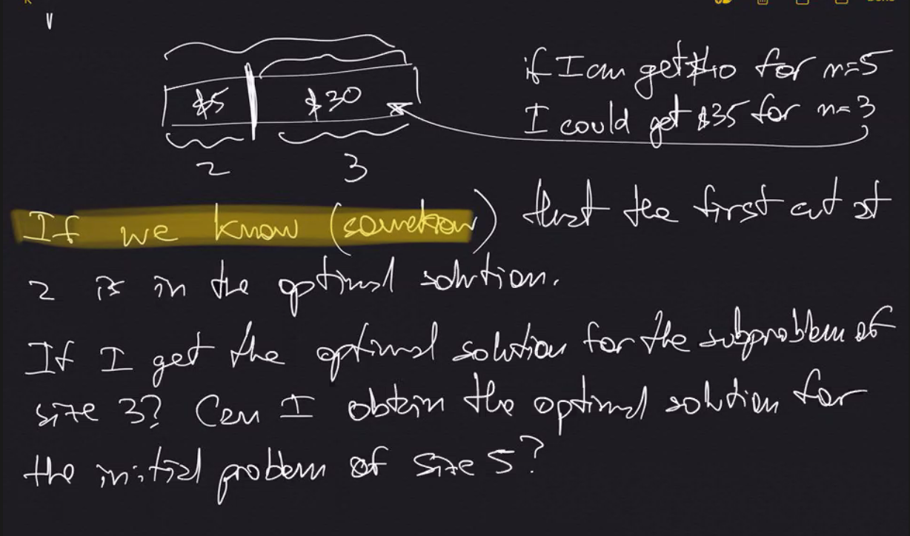

Note:  
If you know the optimal solution for the subproblem of size 3, the optimal solution for initial problem of size 5 is the sum of the solution for size 3 and size 2.

**Making Change: O(x*n)**

Input: Amount x dollars, d [0..n] coin denominations

Output: minimum number of coins needed to make change out of x

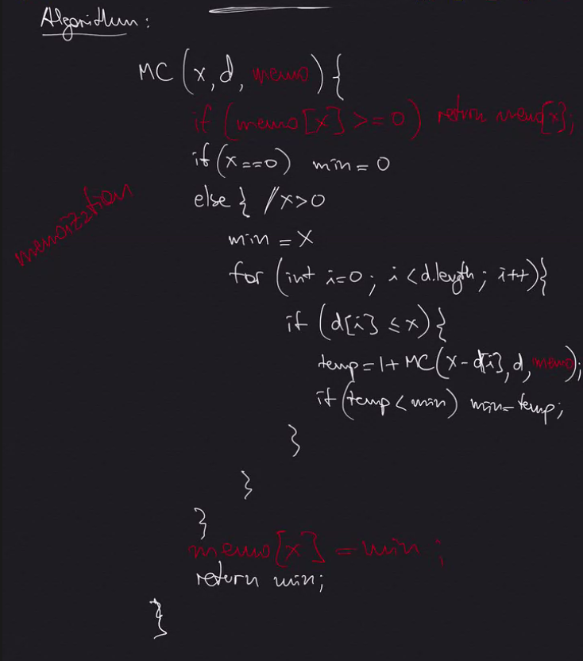

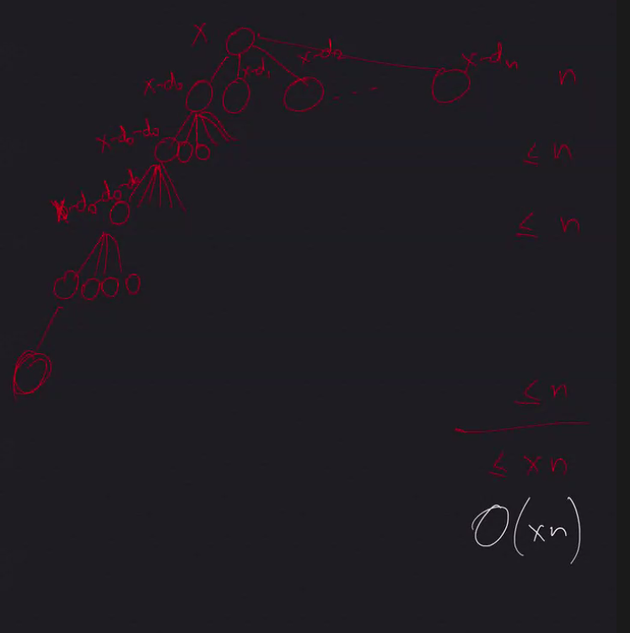

**Elementary Graph Algorithms**

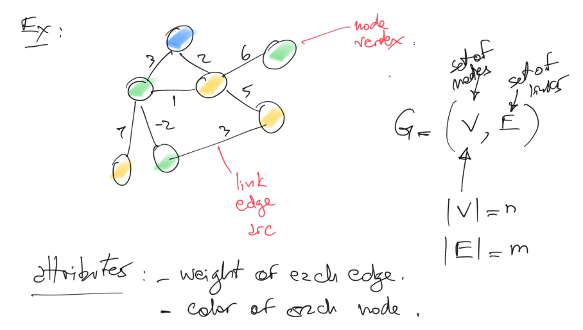

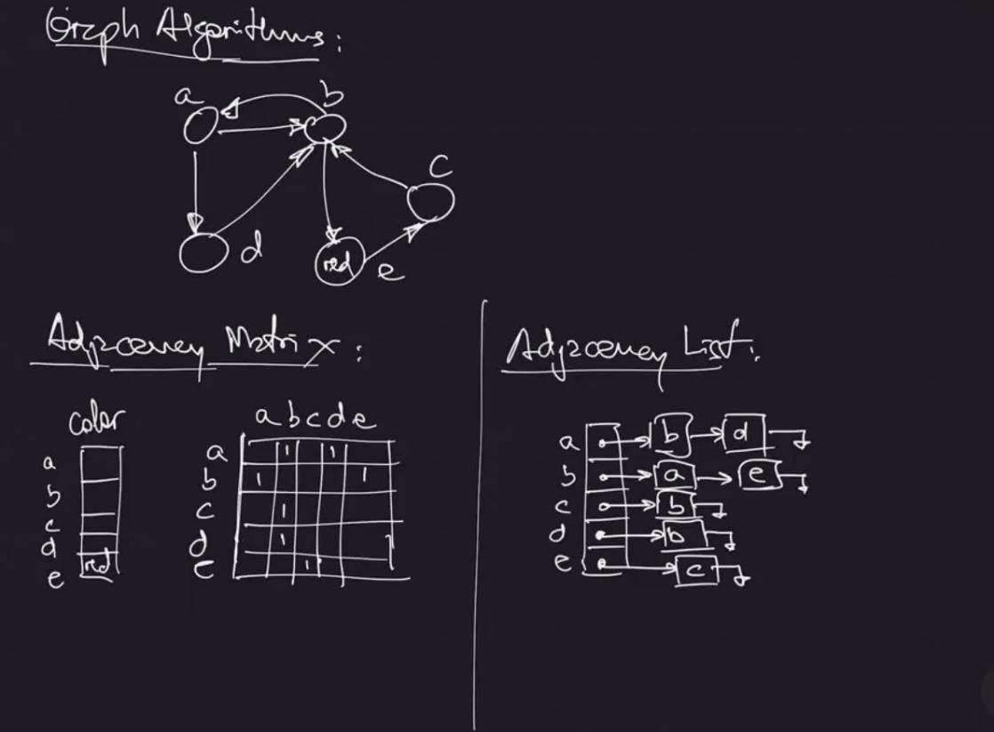

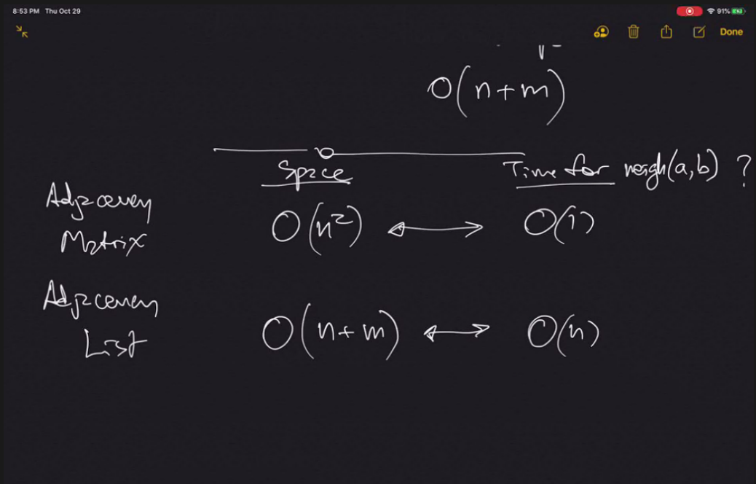

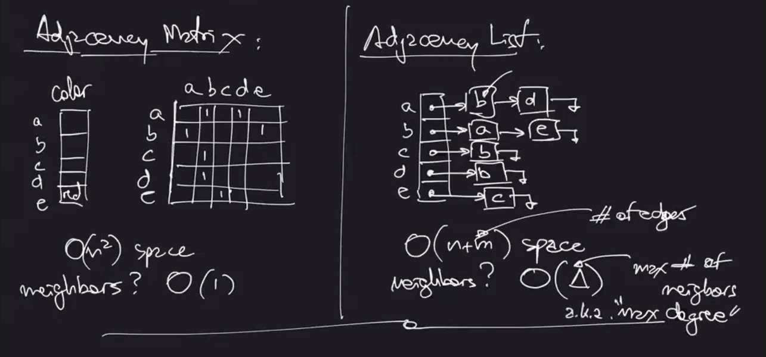

Adjacency Matrix

* Usually stores true/false for whether a connection is present
* Stores other attributes in separate arrays (such as colors)

**Depth First Search: O(n+m)**

If we can go to a neighbor that has not been visited yet, we do it.

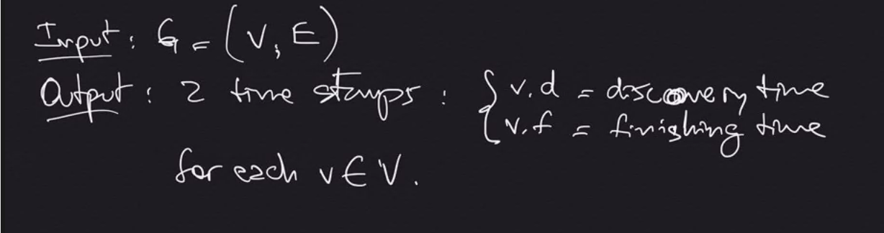

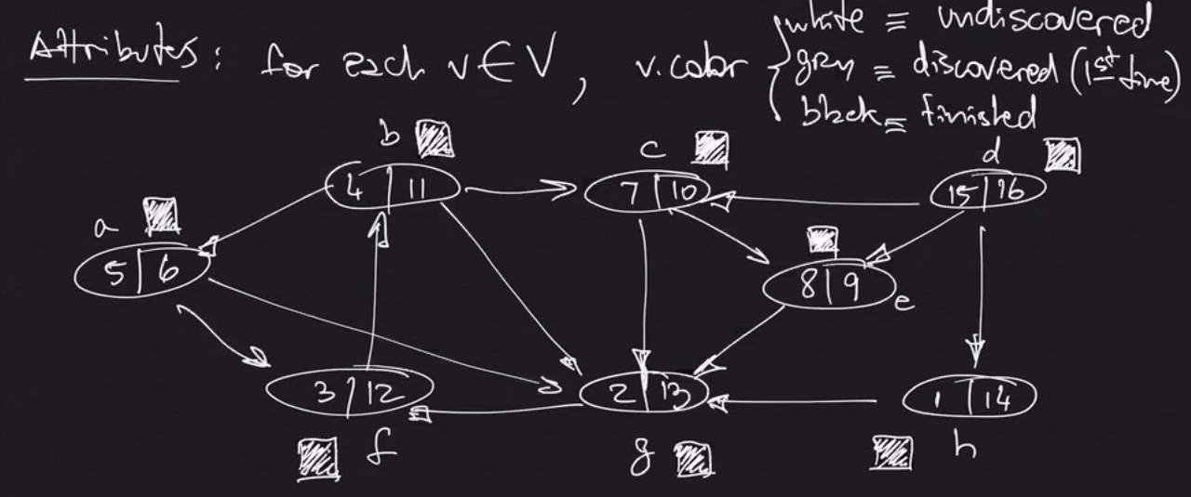

**Note:**

V = Vertices, E = Edges

|V| = n

|E| = m

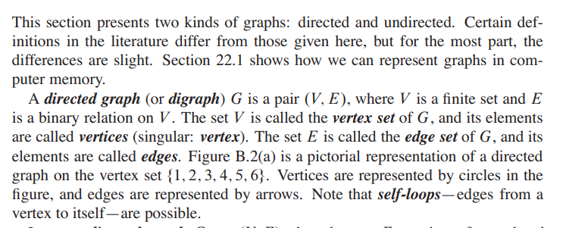

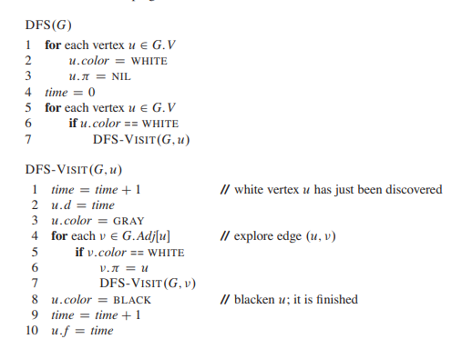

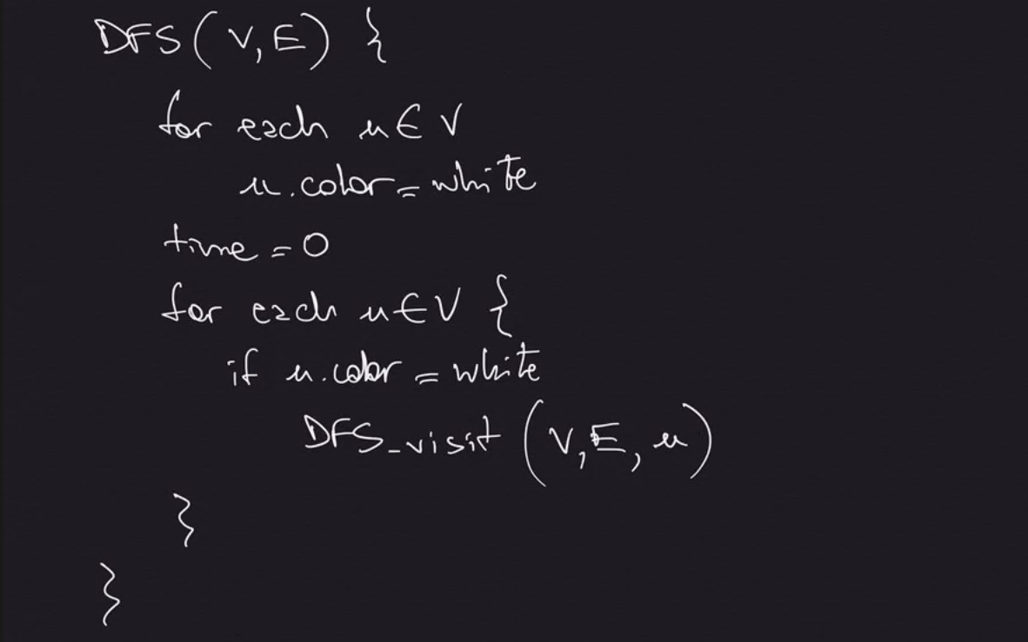

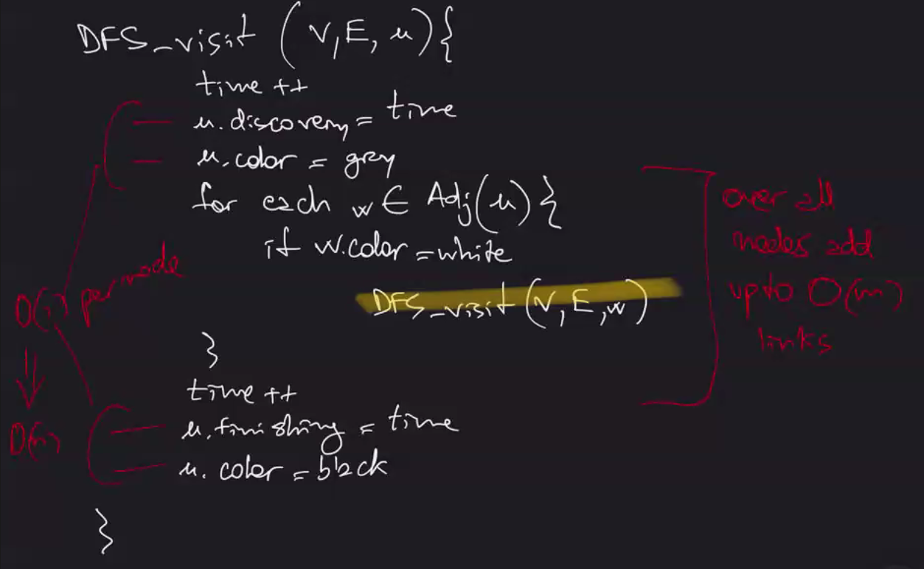

**O(n+m) – Big O will take care of which ever one is bigger (if G is stored in an adjacency list)**

**Breadth First Search: O(n+m)**

Go to all the neighbors before going to neighbors of neighbors. One level at a time. Distance away from starting node is important and is output (infinity if not connected).

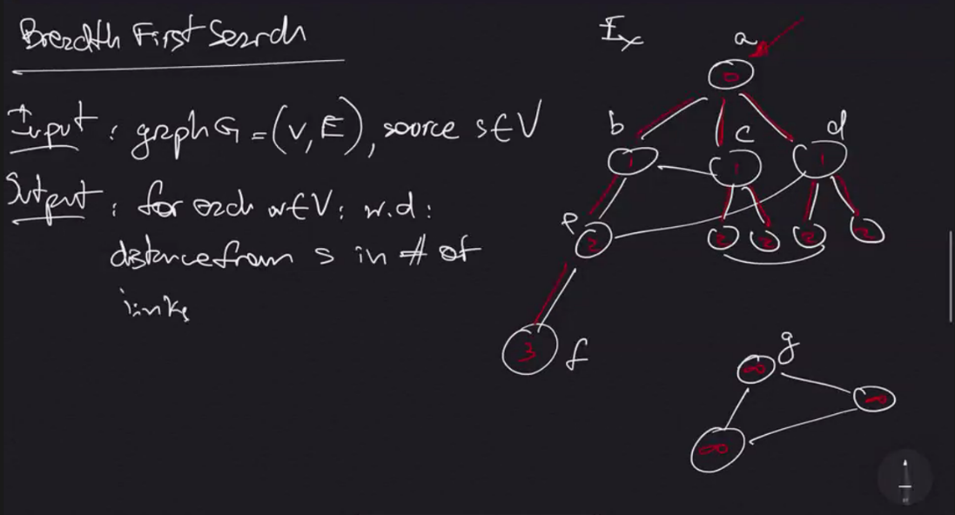

**Note:**

A queue is a data structure with operations enqueue() and dequeue() that maintains a FIFO order.

w = neighbor

s.d = distance from source

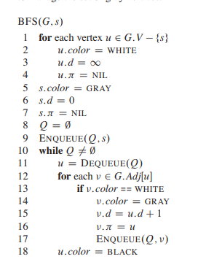

🡨--- O(1) for each vertex, O(n) total

🡨 O(1)

🡨 If G is stored in adjacency list, we look at each edge only twice, so O(m) total

🡨 exactly once for each node, O(n) total

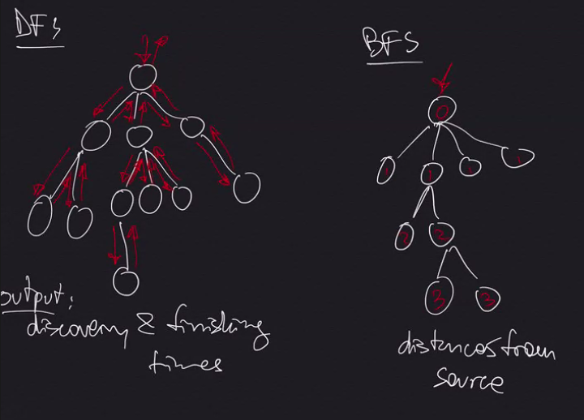

**Note:**

Both DFS and BFS are O(n+m)

**Topological Sort:**

Used with Directed Acyclic Graphs (DAG)

DECREASING FINISHING TIMES

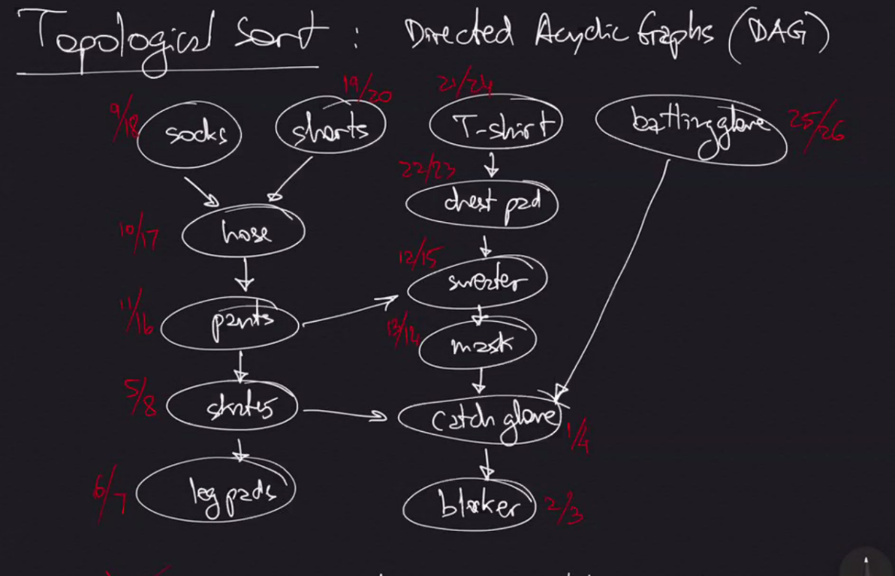

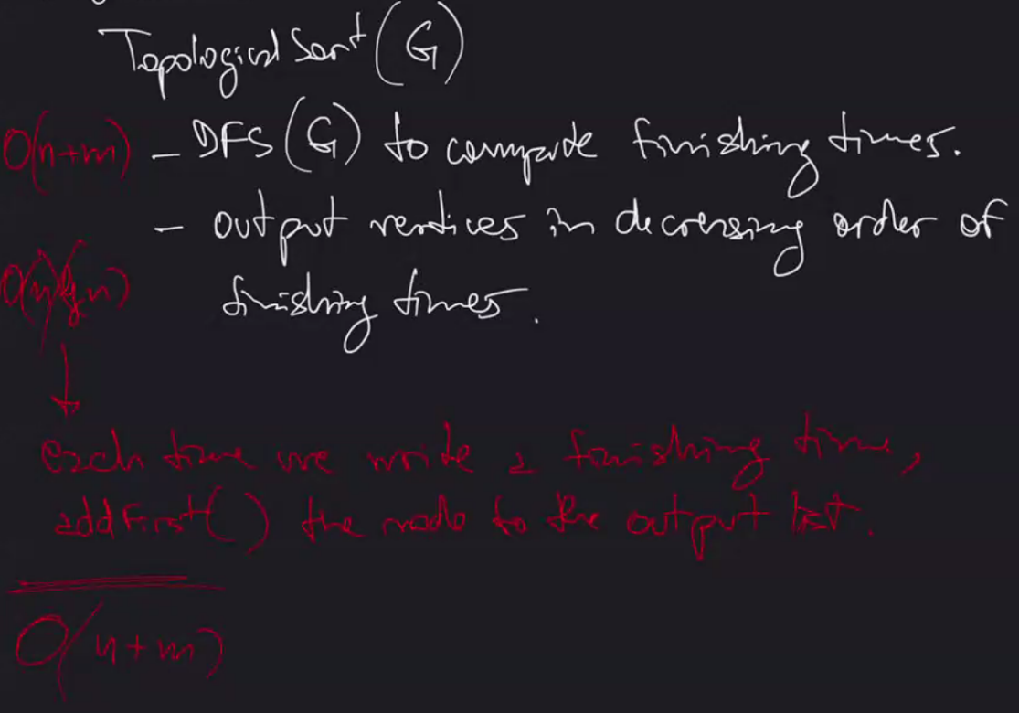

**Note:**

O(n lg n) for outputting in decreasing order can be skipped by inserting nodes to the front of a linked list during the DFS, therefore just O(n+m)

Proof for Topological Sort Correctness:

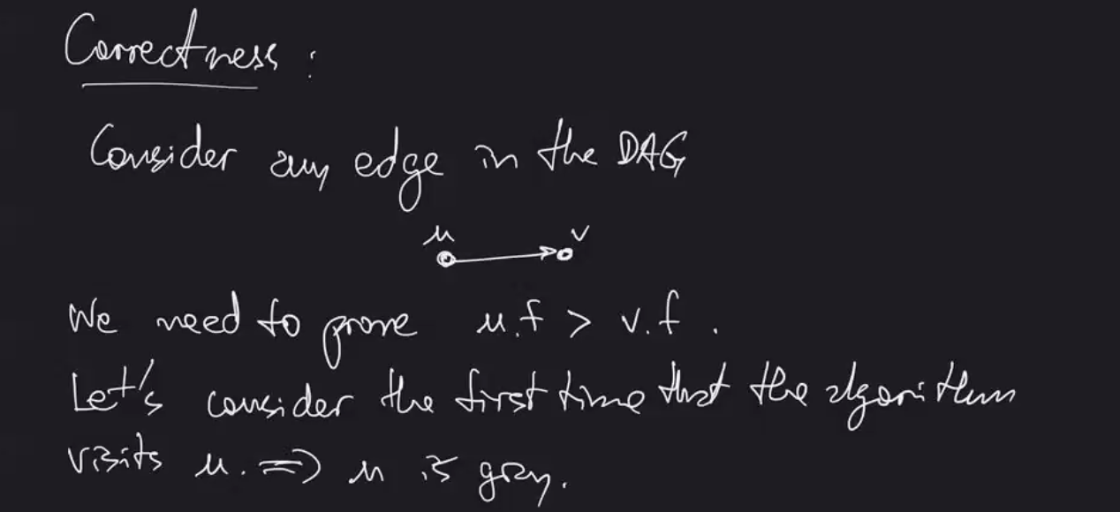

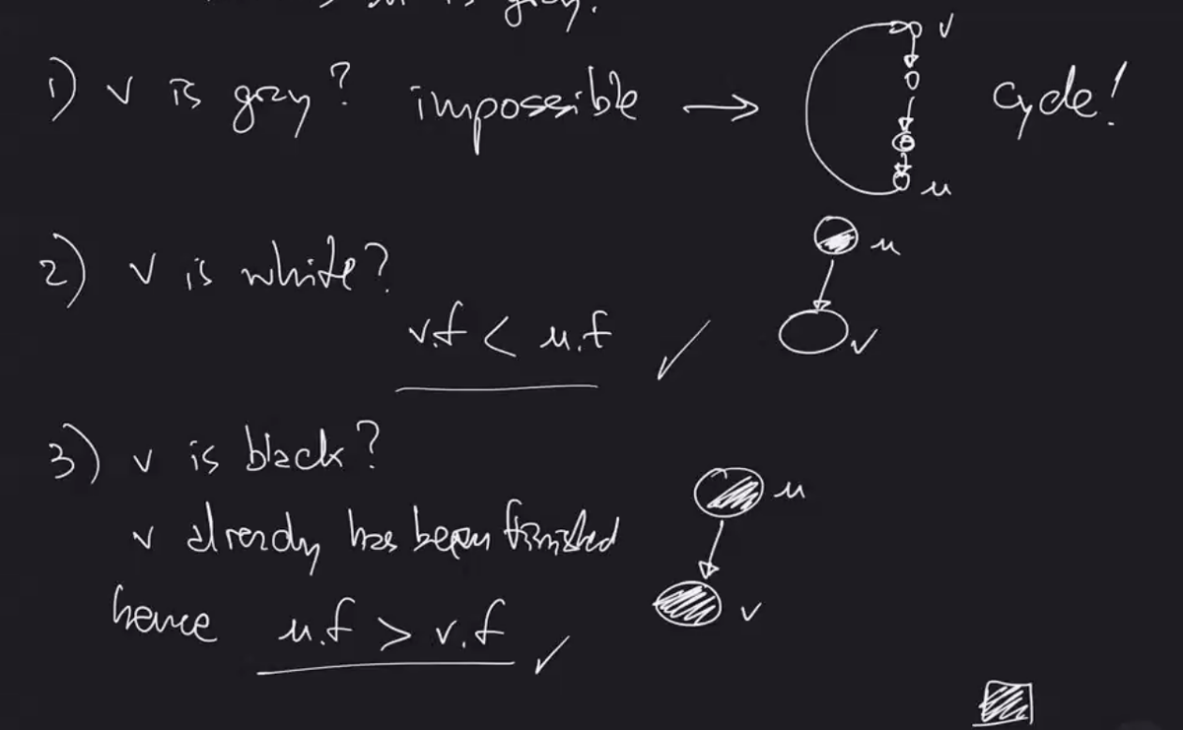

**Strongly Connected Components: O(n+m)**

Input: a directed graph, G

Output: A partition of the set of nodes such that for each subset, every pair of nodes is connected in both directions

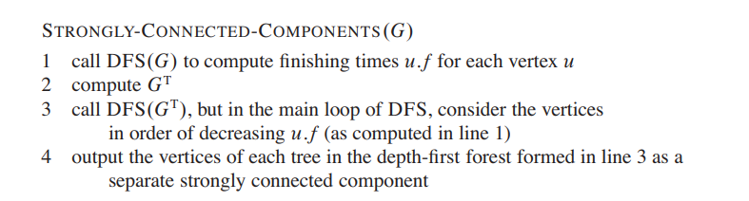

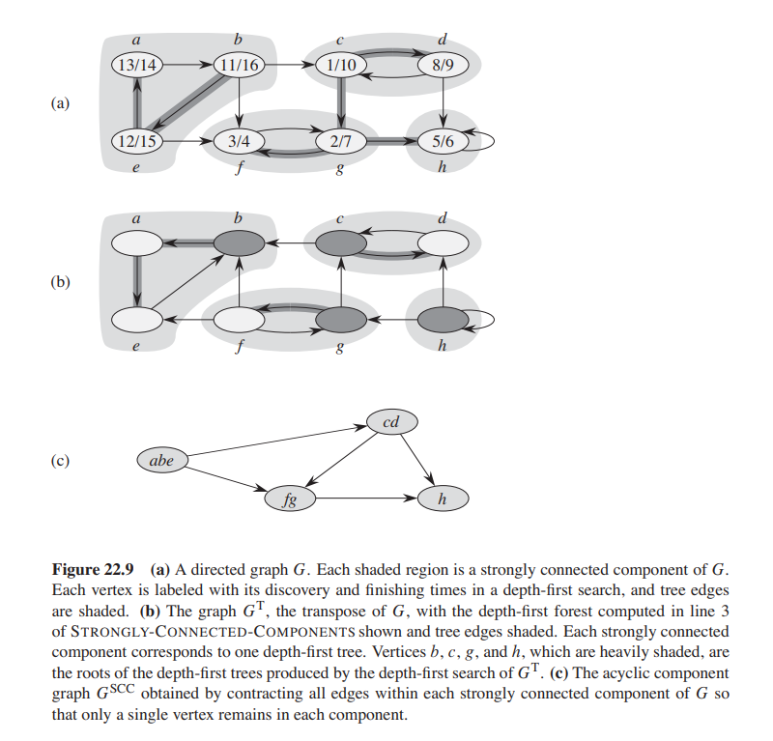

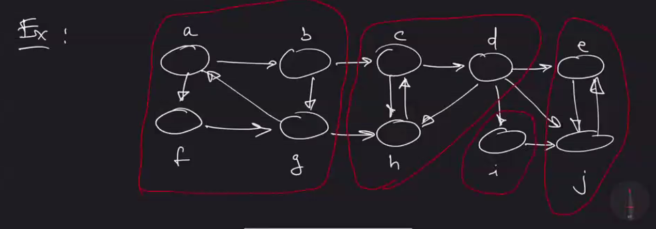

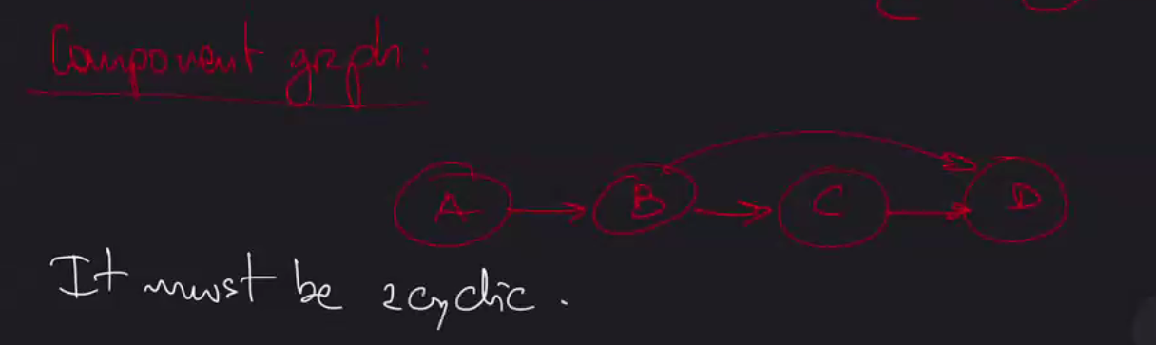

**Note:**

A component graph must be acyclic.

How to know when start/end of each component is?

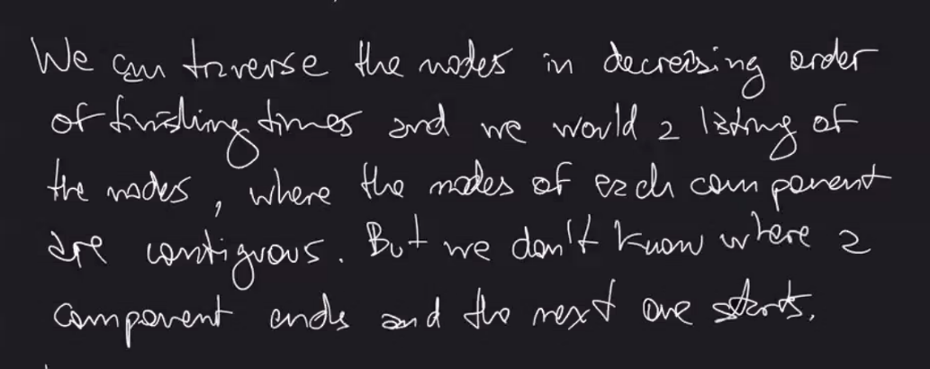

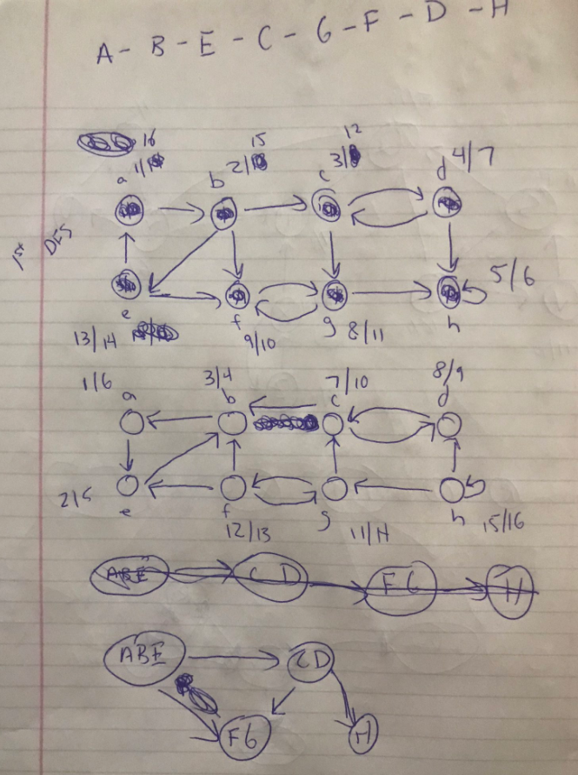

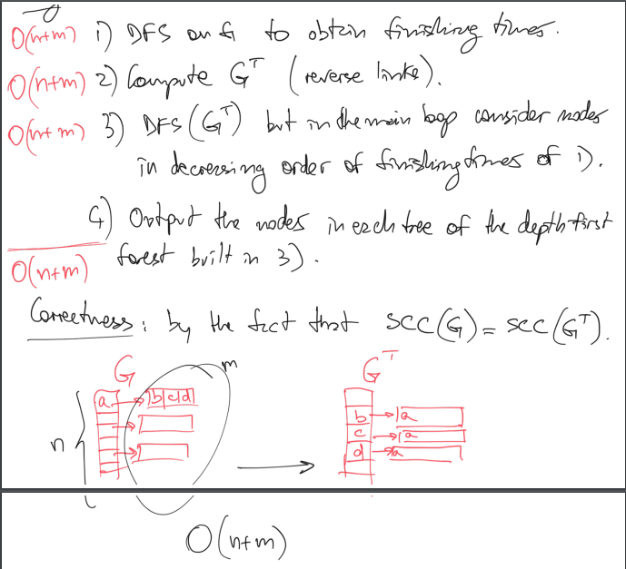

**Minimum Spanning Trees:**

**Kruskal’s Algorithm: O(E lg V)**

1. Sort all edges by weight

2. For each edge in that order, if it does not form a cycle, add it to the tree

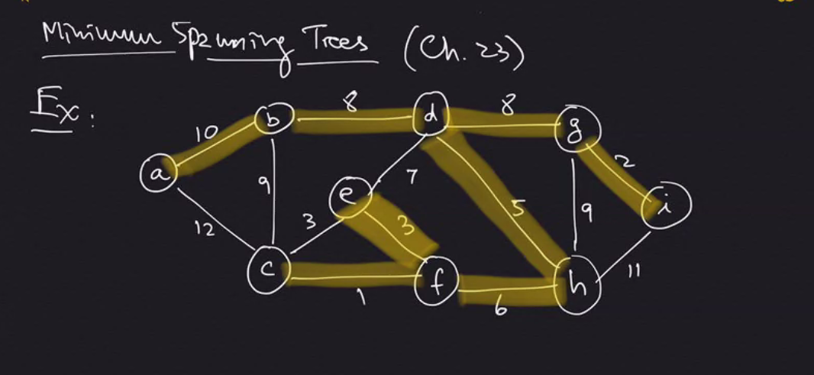

Proof of correctness:

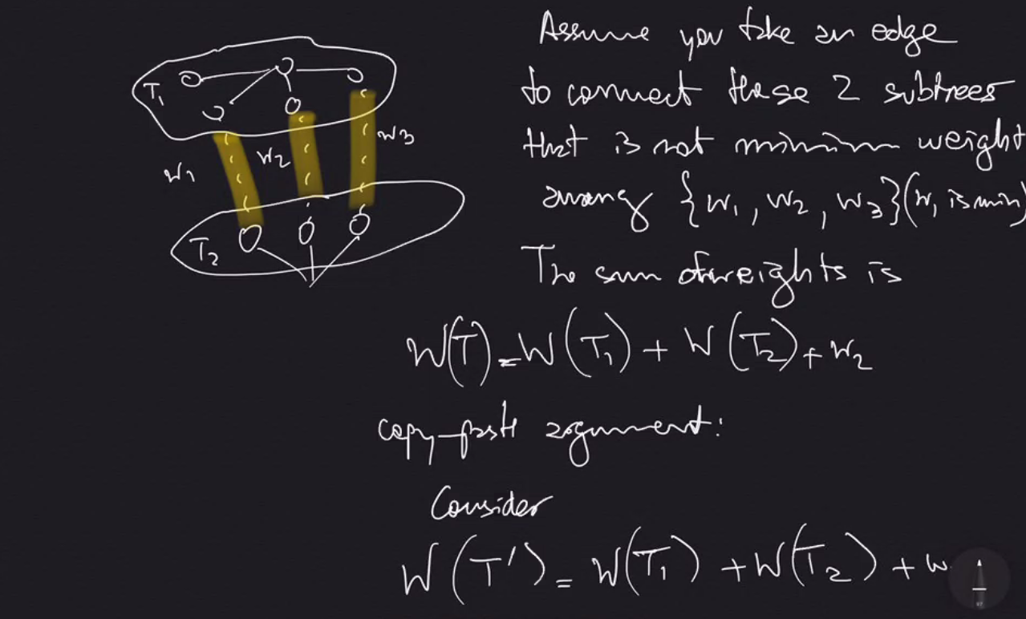

Copy Paste argument – shows that using smaller weight (w1) would lead to smaller overall weight.

**Note:**

In order to check if a new edge forms a cycle with current tree, we can use DFS which takes O(V+E)

We can use Union-Find (aka Disjoint Sets) Data Structure

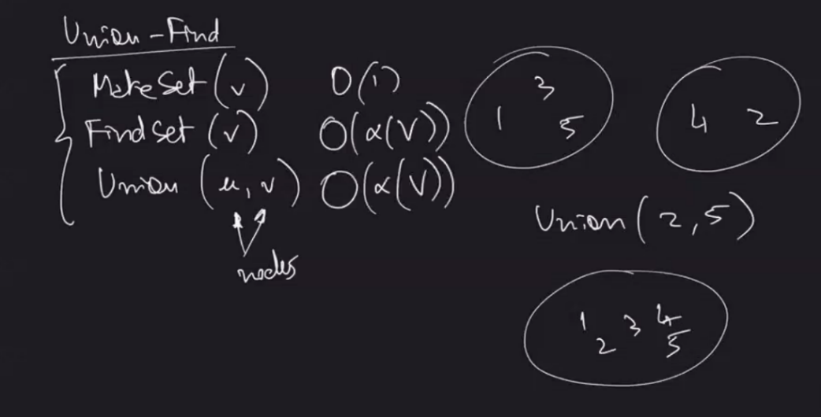

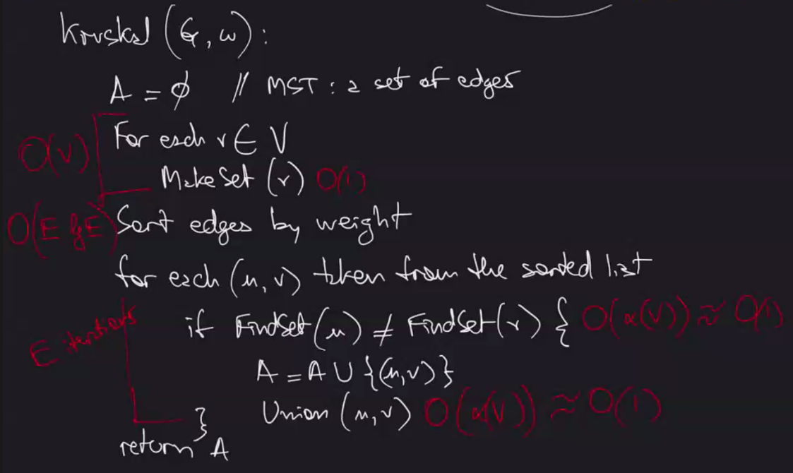

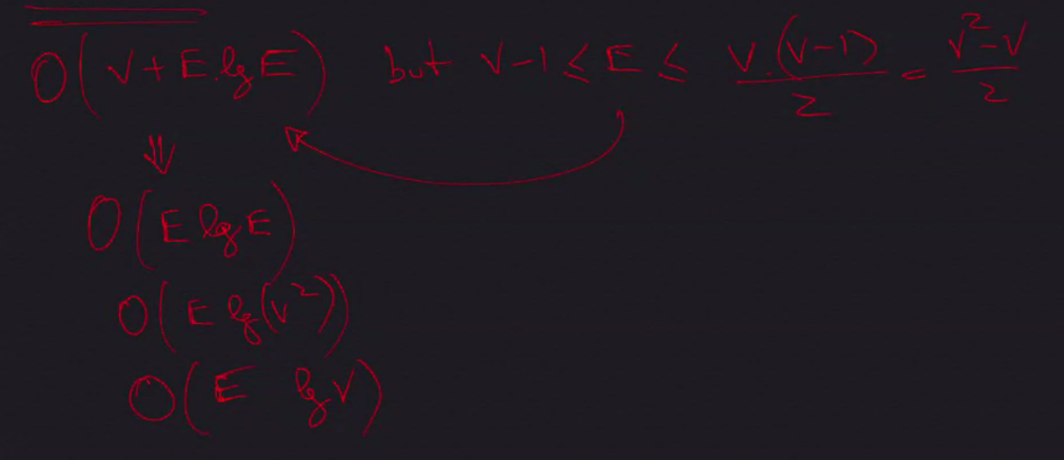

**O (E lg (V^2)) 🡪 O (E 2 lg V) 🡪 O (E lg V) REMOVE constant 2**

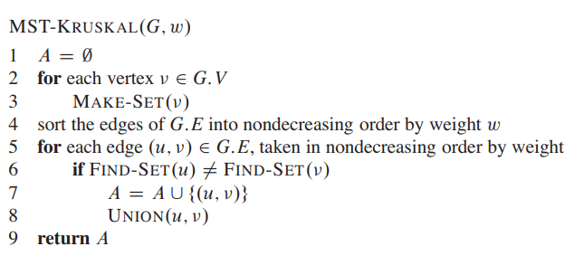

**Prim’s Algorithm: O(E lg V)**

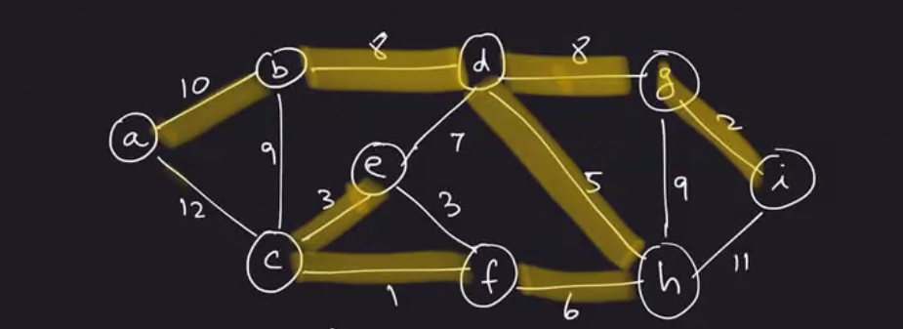

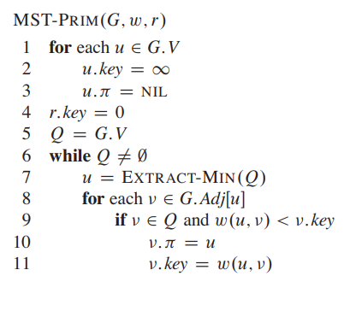

Prim’s Algorithm:

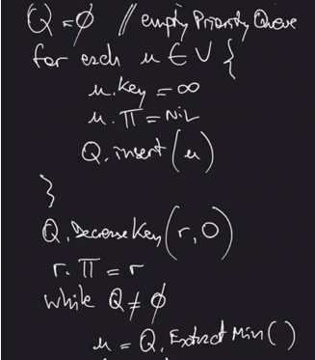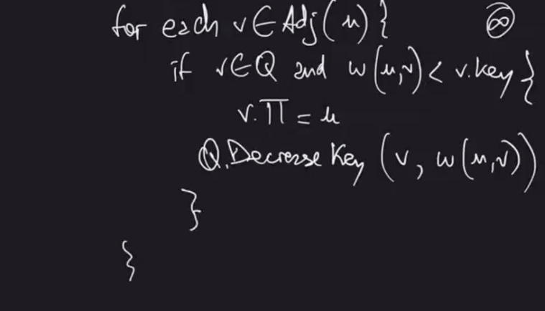

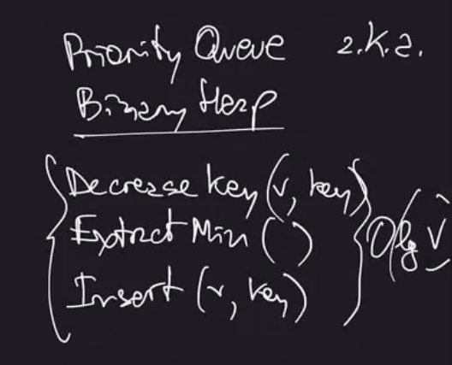

**Note:**

Pi symbol = parent of vertex

**Single Source Shortest Path:**

Used to find the shortest path between two nodes

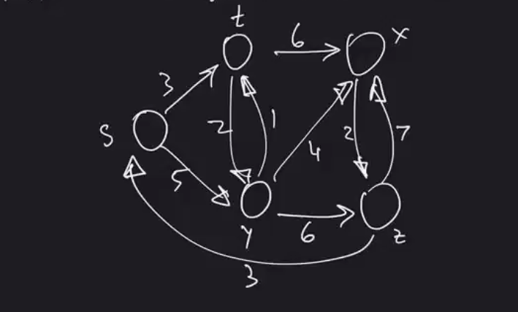

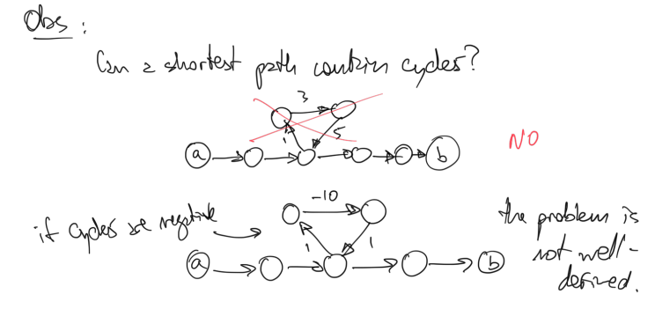

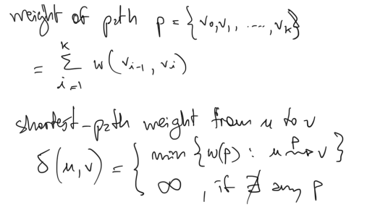

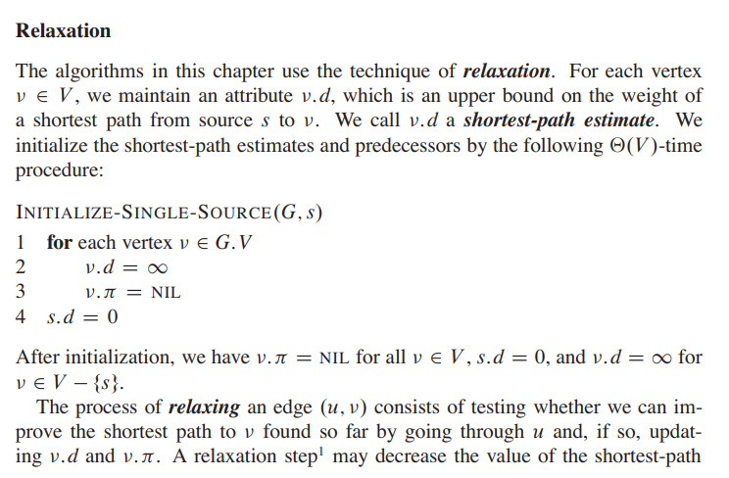

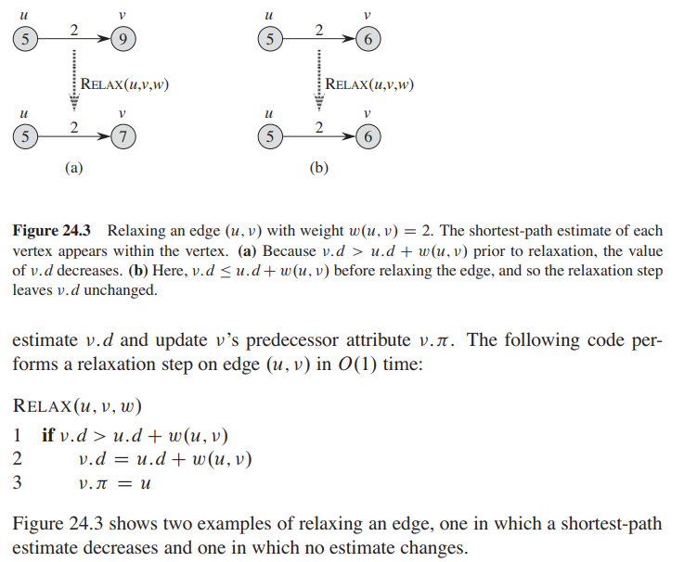

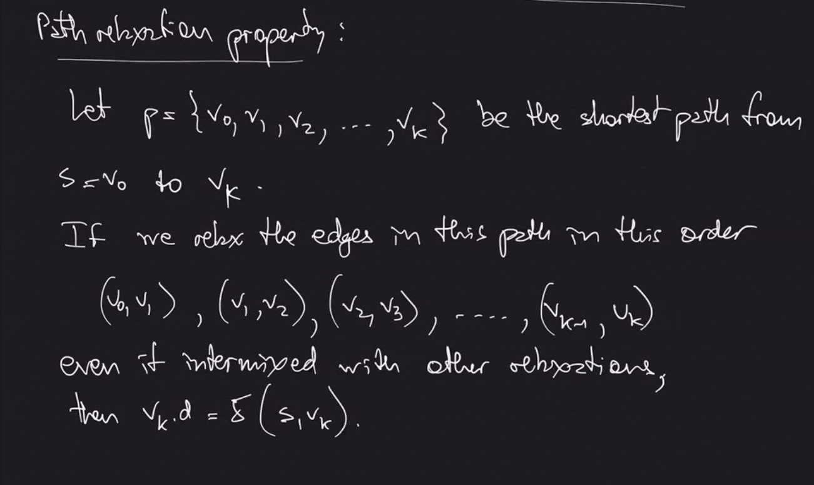

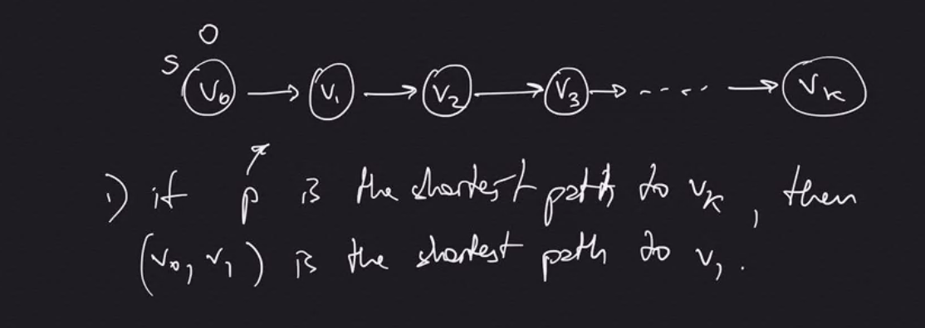

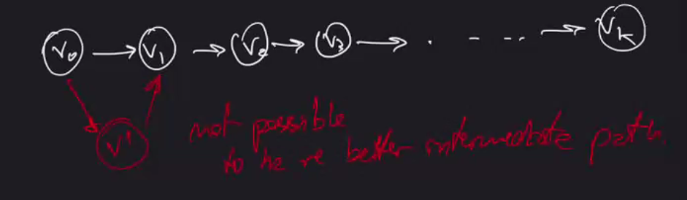

How do we know which link to relax first so that (V0 – V1) is relaxed? Relax them all!

**Belliman-Ford Algorithm: O(V*E)**

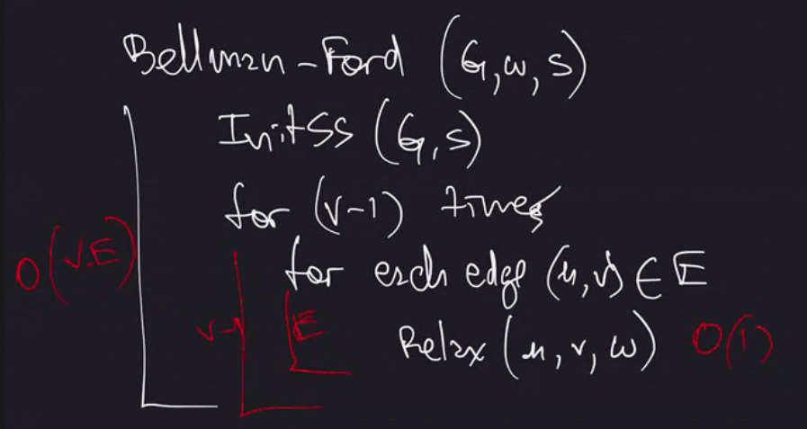

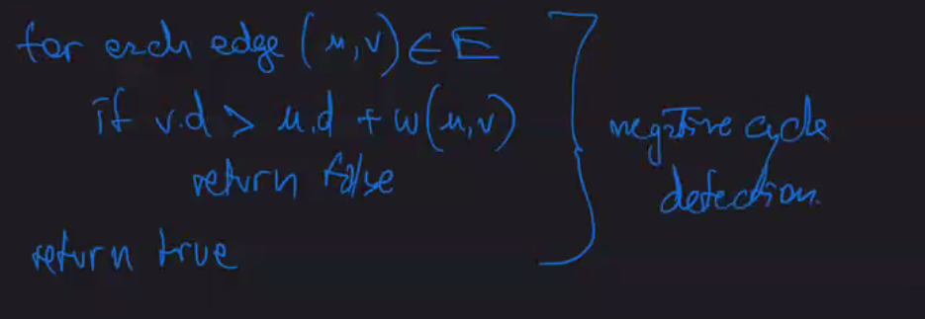

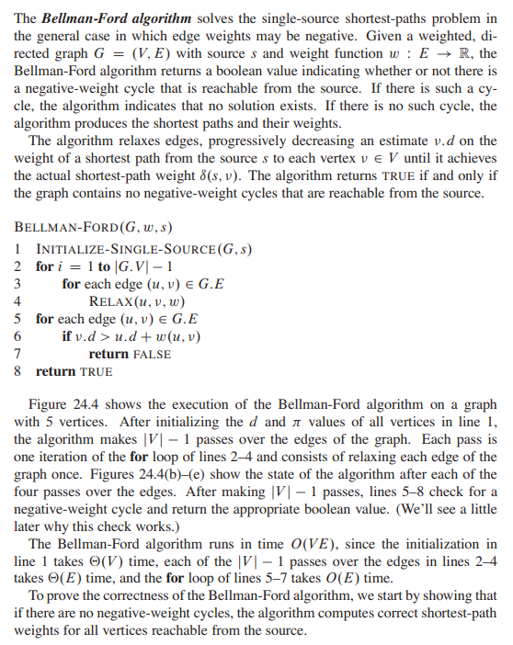

**Note:**

Belliman-Ford detects negative cycles and negative edges. (Dijkstra’s Algorithm does not, but it achieves better run time if it has no negative cycles)

**Belliman-Ford runs in O(V*E)**

**Dijkstra’s Algorithm: O(E lg V)**

